How to View Credit Card Number

The full credit card number can now be viewed through Deposit/Refund Record in all Contract modules by users with adequate security permission. Click the Deposit/Refund Record button to bring up the Deposit Window. Notice that a new View Card Number button has been added to each of the Credit Card Deposit/Refund and Credit Card Authorizations sections.

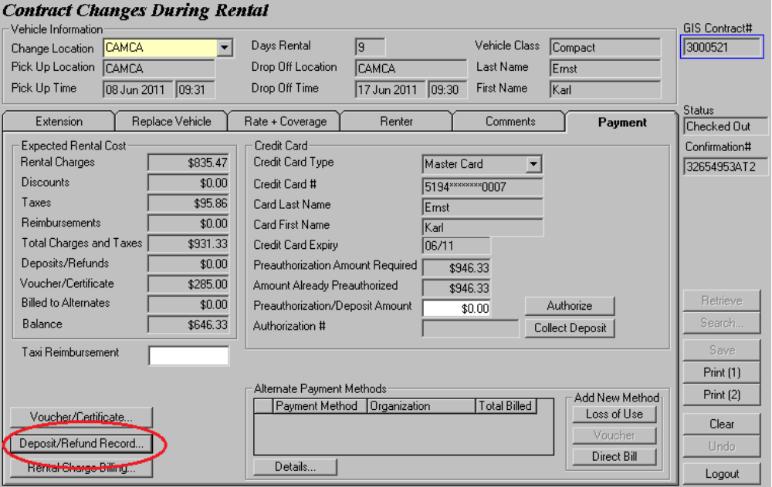

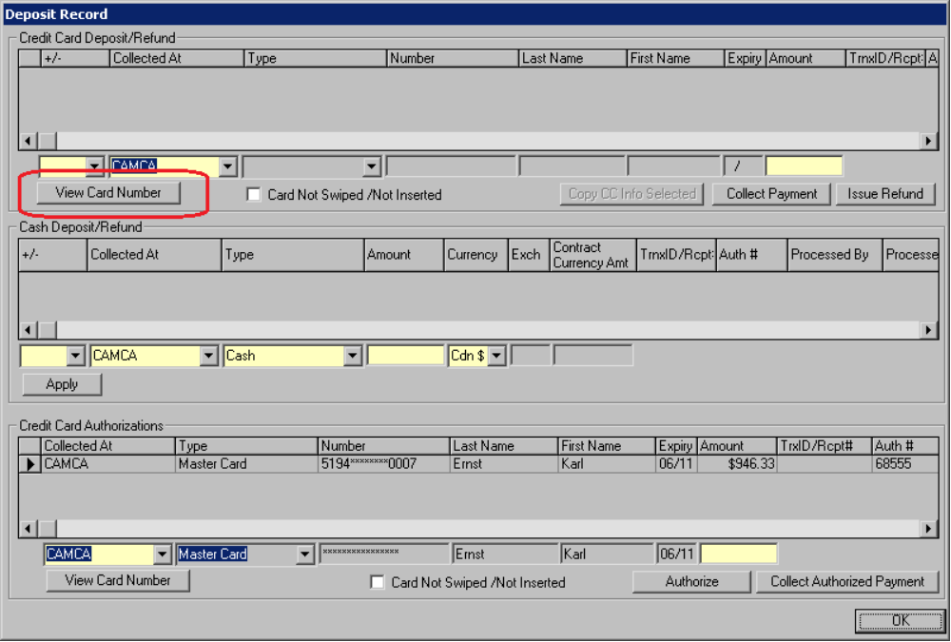

To view a card number, you must first select the credit card by highlighting it in the grid.

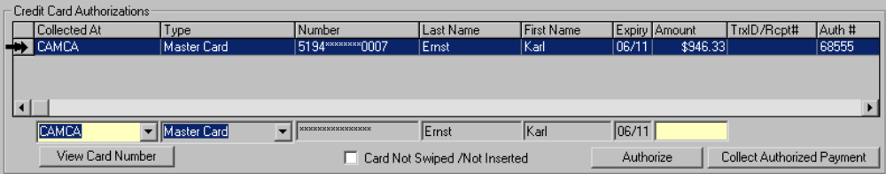
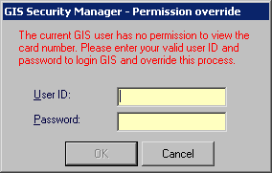

Now select the View Card Number button. GIS will pop up a GIS Security Manager window to make sure that you are authorized to see the full credit card number.

Permission override settings can be changed by authorized admin users through the GIS security tool.

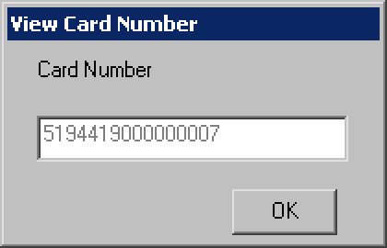
Once you have authenticate yourself, a View Card Number will be displayed with the credit card number.

Note that you can only view a credit card number if the grid contains a credit card.

